**Types Of Function**

There are 3 types of function

* + Function Declaration
  + Function Expression
  + Arrow Function

Function Declaration :

<html>

    <body>

    <h2>Function Declaration</h2>

    <script>

        function add(a, b) {

            console.log(a - b);

        }

        add(11,3);

    </script>

    </body>

    </html>

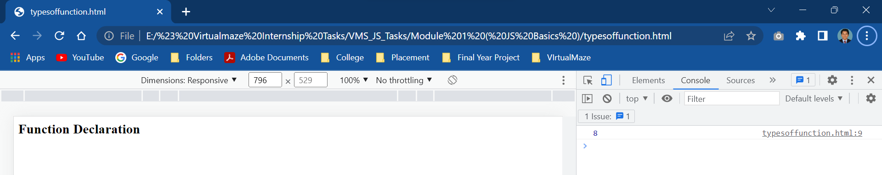

Function Expression :

   <html>

    <body>

    <h2>Function Expression</h2>

    <script>

        var add = function(a, b) {

            console.log(a+b);

        }

        add(2, 3);

    </script>

    </body>

    </html>

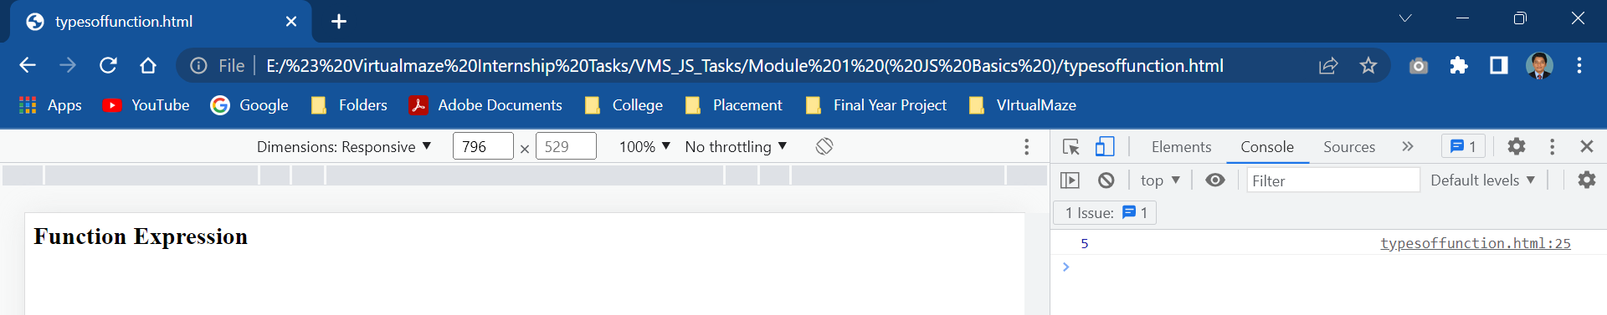

Arrow Function :

It is used to shorten the code.

In javascript without using “**function”** keyword we can use the arrow symbol.

 <html>

        <body>

        <h2>Arrow Function</h2>

        <script>

            // Single line of code

            let add = (a, b) => a + b;

            console.log(add(11, 7));

        </script>

        </body>

        </html>

